FOREWORD

Accreditation provides a structure and indicates a process to achieve reliable testing and calibration reports and certificates. Accreditation is the mechanism to assure customers of the competence of laboratories and other types of conformity assessment bodies.

The National Accreditation Board of the Malta (NAB-MALTA) is the single national accreditation body appointed as per Article 4 of Regulation (EC) No. 765/2008 with responsibility for accreditation in accordance with the relevant normative documents.

International trade relies on certificates and reports issued by competent bodies. Confidence in certificates and reports is achieved by accreditation. Confidence in accreditation is based on a series of confidence building steps between the accreditation bodies and accredited conformity assessment bodies and the assurance given by the accreditation body that the accredited conformity assessment body constantly implements the relevant criteria and maintains and continuously develops its competence as defined in the relevant standard. This assurance is achieved through accreditation which includes regular on-site assessments and other types of accreditation activities.

The services of the NAB-MALTA are accessible to all applicants whose requests fall within the current activities as offered by the NAB-MALTA and which are in compliance with the cross-border accreditation requirements as stipulated in Article 7 of Regulation (EC) 765/2008. Access is not conditional upon the size of the applicant laboratory or membership of any association or group.

For the scope of this publication, the masculine gender shall also refer to the feminine gender.

SCOPE OF PUBLICATION

This publication has been drawn up to set out the rules applicable to applicant and accredited CABs for

use of the NAB-MALTA accreditation symbol,

references to accreditation

reference to EA MLA signatory status.

This is a mandatory document.

This document will come into effect as from June 2021.
Contents

FOREWORD 1
SCOPE OF PUBLICATION 1
1. INTRODUCTION 3
2. DEFINITIONS 3
3. GENERAL REGULATIONS 4
4. REPORTS, CERTIFICATES AND LABELS 9
5. SUBCONTRACTED TESTS, CALIBRATIONS AND INSPECTIONS 13
6. DOCUMENTS, ADVERTISING AND PUBLICITY 13
7. REPRODUCTION OF THE ACCREDITATION SYMBOL 15
8. USERS OF ACCREDITED SERVICES 16
9. MISUSE OF ACCREDITATION SYMBOL OR ACCREDITATION STATUS 18
ANNEX A - Accreditation Symbols 19

1. INTRODUCTION

1.1. These regulations set out the terms and conditions for the use of the NAB-MALTA accreditation symbols, text reference to accreditation and reference to EA MLA signatory status by Conformity Assessment Bodies (CABs).

1.2. Applicant and accredited CABs shall be familiar with the following documents:

EN ISO/IEC 17011 Cl.4.3 | - | Conformity Assessment – General requirements for accreditation bodies accrediting conformity assessment bodies; Reference to accreditation and use of symbols.
EA 3/01 M | - | EA Conditions for the Use of Accreditation Symbols, Logos and other claims of accreditation and reference to the EA MLA Signatory status
ILAC-P8 | - | Supplementary Requirements and Guidelines for the Use of Accreditation Symbols and for Claims of Accreditation Status by Accredited Conformity Assessment Bodies.

1.3. These regulations are an integral part of the contract signed between the NAB-MALTA and the CAB.

1.4. Accredited CABs use the accreditation symbol to demonstrate third-party attestation of their competence to carry out specific conformity assessment tasks.

2. DEFINITIONS

The following definitions, based on Clause 3 – Terms and Definitions of EN ISO/IEC 17011 (Conformity assessment – General requirements for accreditation bodies accrediting conformity assessment bodies) and EA3/01 apply:

2.1 ‘Accreditation body logo' is the logo used by the NAB-MALTA to identify itself and to communicate its name. This form of the logo shall only be used by the NAB-MALTA.

2.2 ’Accreditation symbol’, is the symbol issued by the NAB-MALTA to be used by the accredited CAB to indicate its accredited status. The ownership of the symbol is vested in the NAB-MALTA and it is a combination of the NAB-MALTA logo in association with the registration number and identification of the accredited area.

2.3 ‘Conformity assessment body’ – CAB, is a body that performs conformity assessment services and that can be the object of accreditation.

2.4. ‘Reference to accreditation’ is one example of a claim of accreditation status and consists of a text or a statement used by an accredited CAB to refer to its accreditation, identifying the accreditation number/code and the national accreditation body (NAB).

2.5 ‘Reference to EA Multilateral Agreement (MLA) signatory status’, is a statement or text used by a NAB or an accredited CAB to refer to the NAB signatory status of the EA MLA for a given accreditation field.

2.6 ‘Accreditation field’, is the unique combination of a conformity assessment field (EA MLA Level 2) and a standard containing requirements for conformity assessment bodies (CABs) performing that activity (EA MLA Level 3), e.g.: Testing & EN ISO/IEC 17025.

2.7 ‘Accredited report/certificate’, A report or a certificate containing conformity assessment results covered by the CAB’s accreditation scope and bearing the accreditation symbol or an equivalent reference to accreditation. Throughout the text it should read report and/or certificate as applicable, even if only report is mentioned.

3. GENERAL REGULATIONS

3.1 Whenever the CAB wishes to use the accreditation symbol or make reference to its accreditation, the latter shall obtain the NAB-MALTA’s written consent prior to any release, including the use of the symbol on promotional material, inspection tags, web sites, quotations or proposals by using the notification of change form, NABG11.

3.2 CABs shall only be permitted to use the NAB-MALTA accreditation symbol, to make text reference to accreditation and/or to make reference to the EA MLA signatory status if:
    - they are accredited, and
    - comply with the relevant rules set out by the NAB-MALTA

3.3 The accredited CAB shall at no time and under no circumstances use the accreditation symbol without its associated registration number, reference to the accredited field and to its scope of accreditation. The accreditation symbol shall be as indicated in Annex A.

3.4 CABs shall fully conform to the NAB-MALTA requirements for claiming accreditation status, and when referring to accreditation in communication media such as websites, social media, documents, brochures, or advertising.

3.5 When a CAB’s customer requires an activity, which is covered by the CAB’s scope of accreditation, it is an implicit expectation of the customer to get an accredited report/certificate. So, for conformity assessment activities that are covered by the CAB’ scope of accreditation, the CAB shall issue an accredited report/certificate unless explicitly agreed in a legal or documented arrangement between the CAB and its customer. In these cases, the CAB shall inform its customer that such reports/certificates are not accredited reports/certificates and are consequently not covered by EA MLA.

However, this last possibility cannot be applied when the reports/certificates containing results covered by the accreditation scope are in an area where accreditation is mandatory by law or under contractual conditions (e.g.: under a conformity assessment scheme) or when they are to be displayed or sent to third parties (public or authorities). In such cases, the use of the accreditation symbol or a claim of accreditation status is mandatory, unless prevented by legal or regulatory requirements.

3.6 Accredited CABs shall inform the NAB-MALTA of any misuse or abuse of the accreditation symbol or logo that it encounters.

3.7 Results issued by an accredited CAB without the NAB-MALTA accreditation symbol or without reference made to the accredited status cannot claim presumption of conformity with the clauses of the relevant national, international and European standards EN ISO/IEC 170XX, EN ISO 15189 nor with the provisions of any multilateral agreements signed by the NAB-MALTA (for e.g. EA MLA)

3.8 Text Reference to Accreditation

Where the accredited CAB wishes to make text reference to its NAB-MALTA accreditation rather than using the accreditation symbol it shall, without variation, use the phrase

‘An NAB-MALTA accredited [calibration laboratory] [testing laboratory] [medical laboratory] [certification body] [inspection body] Reg. No. ####’

and shall ensure that this wording is used by any client when referring to the accredited CAB.

3.9 The accredited CAB shall be responsible for the correct use of the accreditation symbol and proper reference to accreditation and in no way shall mislead as to what is accredited (scope) or who holds accreditation.

3.9.1 The accreditation symbol or text reference to accreditation shall be used by the accredited CAB only under the name or the registered trade name of the legal entity in which it holds accreditation.

3.9.2 Whenever an accredited CAB operates from several sites among which at least one is not in the scope of accreditation, the CAB may make reference to accreditation only for work done at the site(s) which is included in the scope of accreditation. When a common document is issued, a disclaimer printed close to the accreditation symbol shall state for instance:
“List of accredited sites and scope available on request” or “List of accredited scopes available on www…”

3.9.3 Whenever a subsidiary belonging to a group has been accredited, there shall not be any confusion as to which part of the group holds accreditation. Communication shall not imply that other subsidiaries have been accredited. In particular, when a common document is to be issued, the list of accredited bodies shall be included.

3.10 CABs shall ensure that no party is misled as to the extent and limitations of its NAB-MALTA accreditation, whether it be in relation to quotations for work, work being undertaken, results being reported, the use of sub-contractors or the advertisement of activities or services, through the positioning of the accreditation symbol or reference to accreditation in commercial documentation or otherwise and will place a similar restriction on its clients. The accredited services shall be clearly and unambiguously identified.

3.11 Applicant CABs shall not make use of any accreditation symbol or refer to the fact that they are somehow accredited by virtue of them having applied for or undergone an assessment. Accreditation can only be claimed once the decisions by the Board have been taken.

3.12 The NAB-MALTA shall always remain the proprietor of the accreditation symbol.

3.13 The accredited CAB shall not make any claims of accreditation without identifying from whom they have received accreditation and shall place a similar restriction on the wording to be used by any client.

3.14 The use of the accreditation symbol shall not state, imply or suggest that the NAB-MALTA approves a calibrated instrument, test or inspection item or product, or that it suggests product approval by the NAB-MALTA.

3.14.1. Accreditation symbols shall not be placed on the products or items which a laboratory has tested or calibrated (except on calibration labels) or which an inspection body has inspected (except on inspection labels).

3.14.2 Accreditation symbols may be used on products or its related packaging for products certified by an accredited Product Certification Body, provided that the accreditation symbol is accompanied with the certification body’s logo and that it is clear that the accreditation body is not the certification body.

3.15 Reference to accreditation through management system certification shall not infer any accredited product certification. The certified body shall not affix the symbol on the products or any of their packages. Likewise, in the case of management system certification in the field of services, the accreditation symbol shall not be used on any related product.

3.16 The Product Certification accreditation symbol may only be used in connection with a product manufactured under an accredited product conformity scheme.

3.17 Suspension of Accreditation

3.17.1 The accredited CAB upon suspension, including partial suspension, of accreditation, shall immediately stop making any claim that it is accredited and shall immediately cease to use the accreditation symbol or any type of claims of accreditation status (including reference to the NAB-MALTA EA MLA signatory status) as well as on any document related to activities falling under its suspension (e.g. reports, certificates, promotional material, stationery, internet web sites, etc.)

3.17.2 The accredited CAB shall contractually bind its clients to immediately discontinue reference to accreditation in all documents, publicity and promotional material (including websites) for the duration of the suspension.

3.17.3 The NAB-MALTA shall use its discretion in cases of temporary suspension (e.g. resulting from temporary absence of resources) provided that no endorsed reports are being issued.

3.18 Withdrawal/Termination of Accreditation

3.18.1 Upon the withdrawal or termination of accreditation, a CAB shall immediately stop making any claim that it is accredited or distributing any document bearing the accreditation symbol or other claims of accreditation and /or reference to the NAB-MALTA’s MLA signatory status.

3.18.2 The accredited CAB shall contractually bind its clients to immediately discontinue reference to accreditation in all documents, publicity and promotional material (including websites) should its accreditation be withdrawn.

3.19 Accreditation and Certification

3.19.1 An accredited CAB shall not refer to its accreditation as certification and shall place a similar restriction on all clients.

3.19.2 Accredited certification bodies shall ensure that all their clients do not refer to certification as accreditation.

3.20 Text Reference to EA MLA Status

Accredited CABs may refer to the EA MLA by including a statement, disclaimer or text reference to the EA MLA on reports and certificates issued to clients. The following is permitted:

3.20.1 Reference to the EA MLA by a statement or disclaimer in combination with the NAB accreditation symbol for example “EA MLA Signatory”

3.20.2 Combination of text reference to accreditation and reference to the EA MLA for example “CAB accredited by NAB under registration number ### for accreditation field covered by the EA MLA”.

3.20.3 Reference to the NAB-MALTA EA MLA signatory status shall be restricted to accredited reports/certificates under the signed EA MLA activity/(ies).

4. REPORTS, CERTIFICATES AND LABELS

4.1 An accredited CAB may use the accreditation symbol in the following cases:

4.1.1 the report contains only results from work performed by the issuing conformity assessment body and contains work which falls under the scope of accreditation.

4.1.2 The accreditation symbol, other claims of accreditation and/or reference to the NAB-MALTA’s EA MLA signatory status shall not be included in reports/certificates themselves containing no accredited results (including electronic reports and certificates and results submitted to clients via e-mail and any enclosed letters, including the stationery on which they are printed).

4.1.3 the report contains results from work performed by the issuing conformity assessment body and by a subcontractor. The subcontractor shall be accredited for the work reported and “a major part” of the reported work is performed by the issuing CAB within its accredited scope.
  - Condition: The issuing CAB must indicate very clearly what has been performed by the subcontractor and that it is accredited.

4.1.4 “A major part” means more than 50% of the reported work. Sometimes this can be measured by the number of tests, sometimes by the number of parameters reported and sometimes by the amount of work involved with each parameter reported. Clearly this has to be judged on a case by case basis.

4.2 Where the accreditation symbol and/or reference to accreditation and/or reference to the NAB-MALTA’s EA MLA status is incorporated in a report or certificate it shall not be used in such a way as to state, imply or suggest that the NAB-MALTA accepts responsibility for the truthfulness of the conformity assessment results covered by accreditation.

4.3 Where the accreditation symbol and/or reference to accreditation and/or reference to the NAB-MALTA’s EA MLA status is incorporated in a report or certificate it shall not be used in such a way as to state, imply or suggest that the NAB-MALTA approves a calibrated instrument, test or inspection item or product, or that it suggests product approval by the NAB-MALTA.

4.4 Where tests/calibrations or inspections outside the scope of accreditation are included, they shall be clearly identified as such by a clear disclaimer (for e.g. “This laboratory (or inspection body) is not accredited for the tests/calibrations (or inspections) marked *”).

- There shall be nothing in any test/calibration or inspection report or certificate or in any attachments or other materials that implies or may lead any user of the conformity assessment results or any interested party to believe that the work is covered by the scope of accreditation when this is not the case.

- If an accredited CAB is also certified by a certification body, the certification body logo shall not be used for the reporting of results of any activity covered by the scope of accreditation. Accredited certification bodies shall ensure that their clients do not use the certification mark on reports and certificates.

4.5 The accredited CAB’s test reports, certificates, or quotations, for work for which the CAB is accredited, shall clearly display the accreditation symbol or reference to accreditation provided that the conditions in 4.1 are fulfilled.

4.6 Reports or certificates bearing the accreditation symbol or other claim of accreditation status shall be signed or approved only by those individuals of a laboratory or inspection body who have been given such approval to sign reports or certificates. Such individuals are normally called authorised or approved signatories.

4.7 Calibration Labels

4.7.1 Calibration labels which bear the accreditation symbol shall only be attached to the item of equipment which has been calibrated using calibration methods covered by the calibration laboratory’s scope of accreditation.

4.7.2 Calibration labels shall not give the impression that the NAB-MALTA approved or calibrated the equipment.

4.7.3 The calibration label should usually include the following information:
- the name and registration number of the accredited calibration laboratory;
- equipment identification;
- date of the current calibration;
- cross reference to the calibration certificate issued in respect of the calibration.

4.8 Inspection Labels

4.8.1 Accredited inspection bodies shall ensure that they restrict the use of inspection labels which bear the accreditation symbol to items which have been inspected under the accredited scope. Only accredited inspection bodies may issue inspection labels bearing the accreditation symbol.

4.8.2 Inspection labels containing the accreditation symbol should not give the impression that the NAB-MALTA has approved or inspected the item.

4.8.3 The label shall clearly indicate that the item has been inspected, e.g., “inspected by ...,” or inspected on …” etc. In addition, the inspection label would usually include the following information:
- the name and registration number of the accredited inspection body;
- equipment identification;
- date of the inspection;
- cross reference to the inspection report issued in respect of the inspection.

4.9 In the case of certification of management systems, certification bodies (CBs) shall issue accredited certificates if they concern scopes for which they are accredited in accordance with the IAF Resolution 2016-17.

4.10 In the case of certification of products, CBs shall issue accredited certificates if they concern scopes for which they have been accredited in accordance with the IAF Resolution 2018-13.

4.11 Opinions and Interpretations

4.11.1 A laboratory is likely to issue reports incorporating the symbol and containing opinions, interpretations or other material relating to investigational activities. When such statements are outside the scope of accreditation, the report or certificate shall include, close to the symbol or to the expression of opinion, a disclaimer such as “The opinions/interpretations expressed in this report are outside the scope of this body’s accreditation”.

4.12 The use of the NAB-MALTA symbol or other claim of accredited status depends on reports or certificates being signed by a signatory or signatories whose authorisation(s)/approval(s) encompass(es) the scope of accreditation. The CAB cannot use the NAB-MALTA logo or claim accredited status on reports or certificates in the absence of approved signatories.

4.13 For management system certification bodies, for a certificate or other certification document to be regarded as accredited it shall be issued by a certification body in accordance with the conditions of its accreditation and unambiguously identify the NAB-MALTA and the issuing certification body.

4.14 Accreditation symbols other than the Testing and Calibration symbols may not be used on test and calibration reports and certificates, respectively.

4.15 Reference to Quality Management System

4.15.1 A laboratory accredited to EN ISO/IEC 17025 may mention that it operates a quality management system on its reports and certificates using the following statement:

“This laboratory is accredited in accordance with the recognised International Standard EN ISO/IEC 17025. This accreditation demonstrates technical competence for a defined scope and the operation of a laboratory quality management system (refer to joint ISO-ILAC-IAF Communiqué dated April 2017)”

4.15.2 A medical testing laboratory accredited to EN ISO 15189 may use an equivalent statement quoting EN ISO 15189 as the accreditation standard and referring to the joint ISO-ILAC-IAF Communiqué dated September 2015.

4.15.3 An inspection body accredited to EN ISO/IEC 17020 may use an equivalent statement quoting EN ISO/IEC 17020 as the accreditation standard and referring to the joint ISOILAC-IAF Communiqué dated September 2013

4.15.4 Accredited CABs choosing to use the above statement on reports or certificates should also either supply, or provide access to (via a website), the Joint ISO-ILAC-IAF Communiqué as part of the package for its customers.

5. SUBCONTRACTED TESTS, CALIBRATIONS AND INSPECTIONS

5.1 Whenever an accredited CAB includes results of subcontracted tests, calibrations or inspections then:

- the accredited CAB shall take full responsibility for the subcontracted tests, calibrations or inspections and has informed the customer of the proposed subcontracting and, where appropriate, has obtained prior written approval from the customer;
- approval shall be obtained from the subcontractor to report excerpts from the subcontractor’s report of certificate;
- the subcontractor shall itself be accredited for the specific tests, calibrations or inspections concerned and the results have been included in the subcontractor laboratory’s or inspection body’s report or certificate.

5.2 If the subcontractor is not accredited by the NAB-MALTA, Clause 5.1 shall only apply if the two accreditation bodies are signatories for the EA MLA for the conformity assessment activities concerned. The accreditation symbol of the accreditation body accrediting the subcontractor shall not be used by the subcontracting CAB on the test reports or certificates.

5.3 If results from non-accredited subcontractors are included in reports or certificates the requirements of Clause 4.4 shall be met completely (i.e. the results are clearly indicated as being outside the scope of accreditation).

5.4 Where all tests, calibrations or inspections were subcontracted to a CAB that is not accredited, none of the accreditation symbols or reference to accreditation may be used on reports or certificates issued by the accredited subcontracting CAB and no stationery relating to the report or certificate may include any reference to or implication of its accreditation.

5.5 The accreditation symbol shall not be used by an accredited CAB’s subcontractors that are not accredited by the NAB-MALTA.

6. DOCUMENTS, ADVERTISING AND PUBLICITY

6.1 When the CAB makes reference to conformity assessment activities (CAA) or other services it offers in its publications and/or advertising material CAA and services which do not fall under the CAB’s accreditation scope, it shall be clearly and unambiguously identified which CAA are covered by the scope of accreditation.

6.1.1 Materials may include:
- website (s) including social media;
- publicity and advertising material;
- brochures and CAB publications;
- technical literature;
- business reports;
- quotations or proposals for CAA

6.2 CABs shall not provide or make publicly available the accreditation certificate without providing the scope of accreditation. As per 6.3.1 below, the CAB is not to publish any accreditation certificate on its website or social media.

6.3 Websites, Social Media and Publicity Materials

6.3.1 Whenever the CAB wishes to use the accreditation symbol or make reference to its accreditation status on its website or entries in social media sites, the CAB shall not directly upload any accreditation certificate or scope, but directly link the accreditation scope of the CAB from the NAB-MALTA website.

6.3.2 Any reference to accreditation within websites and social media sites shall be hyperlinked to the scope of accreditation from the NAB-MALTA website.

6.3.3 All accredited conformity assessment bodies shall approach the NAB-MALTA prior to the publication of information related to accreditation on a website.

6.4 Letterheads

6.4.1 CABs are not to use letterheads or other corporate paper bearing the accreditation symbol, if none of the conformity assessment activities mentioned in the document are within the scope of accreditation, nor for reporting of conformity assessment results if none of them are within the scope of the accreditation, nor for certifying a product or item.

6.4.2 On commercial documents such as quotations or proposals (including associated stationery) concerning conformity assessment activities which do not fall into the CAB’s accreditation scope, CABs are not to use the accreditation symbol.

6.4.2.1 If a quotation or proposal contains both accredited and unaccredited activities, it should be clearly and unambiguously identified which conformity assessment activities are covered by the scope of accreditation and which are not.

6.4.3 Reference to the NAB-MALTA EA MLA signatory status by accredited CABs on their letterheads and stationery is not permitted.

7. REPRODUCTION OF THE ACCREDITATION SYMBOL

7.1 The accreditation symbol shall be displayed in a form identical to that provided by the NAB-MALTA and shall be uniformly enlarged or reduced as specified in the following sub-paragraphs.

7.2 CABs must ensure that any reproduction of the accreditation symbol is accurate and legible with no degradation and/or distortion.

7.3 Where the accreditation symbol is displayed on an unfolded portion of stationery or area no greater than A4, it shall be displayed in a size no larger than 30mm high.

On larger or smaller portions of stationery the diameter size may be proportionately increased or reduced to an absolute minimum size of 20mm.

7.4 A 3mm-wide border is to be left around the accreditation symbol.

7.5 An accreditation symbol on an unfolded portion of stationery shall be displayed:

(a) only if the logo or title of the accredited CAB concerned is also shown;

(b) with no more prominence than the logo or title of the accredited CAB concerned;

(c) no more than once for each NAB-MALTA accreditation.

7.6 The accreditation symbol shall only be printed in one of the following colours:

(a) single colour which may be;
- black or
- in the case of pre-printed letterhead paper, the prominent colour of the accredited CAB’s letterhead;

(b) three colours which shall be the NAB-MALTA colours;
- Pantone (Blue) 281
- Pantone (Red) 187
- Black

7.7 Embossed, relief or die-stamped versions of the accreditation symbols in the relevant colours or in black and white may also be used in compliance with these regulations. No other versions of the symbol are permitted.

7.8 Reverse image versions of the accreditation symbols are not permitted. Where the symbol needs to be produced on a dark or black background, then its direct background shall be left white.

7.9 CABs may use digital versions of the accreditation symbol provided that they comply with these regulations. Digital versions of the accreditation symbol shall be obtained from the NAB-MALTA.

7.10 The accredited CAB may only display the accreditation symbol on the sheets of its stationery or other items relating to the CAB’s accredited activities, subject to the conditions laid out in these regulations and in the applicable documents of the European Co-operation for Accreditation (EA), with particular reference to EA 3/01. Use of text reference to MLA signatory status by accredited CABs on their letterheads and stationery are not permitted.

8. USERS OF ACCREDITED SERVICES

8.1 Users of the accredited services shall be allowed to use the accreditation symbol or text reference to accreditation for e.g. in promotional material.

8.2 The accredited CABs shall have in place policies and procedures for use of its logo in combination with the accreditation symbol or text reference to accreditation by its clients. In all instances the CABs shall inform the NAB-MALTA prior to the use of the accreditation symbol or text reference to accreditation.

8.3 Clients of accredited CABs shall not be allowed to use the NAB-MALTA accreditation symbol or text reference to accreditation on letterheads, stationery, etc…

8.4 Certification bodies shall ensure that they audit the use of accreditation symbols by their certificate holders.

8.5 Users of accredited management system certification
Accredited certification bodies shall ensure that their clients strictly limit the use of the accreditation symbol to the activity certified by the certification body under its accreditation. The accreditation symbol shall be displayed only in combination with the logo of the certification body (certification mark).

8.6 Users of accredited Product Certification

8.6.1 Accredited product certification bodies may allow their clients to affix the accreditation symbol on the product itself or its related packaging. This shall only be allowed if the NAB-MALTA symbol is displayed in combination with the certification body’s logo. Prior approval shall be sought from the NAB-MALTA.

8.7 Users of an accredited Personnel Certification Body

8.7.1 Clients of accredited certification body for persons shall not use the NAB-MALTA accreditation symbol. However certified persons shall have the opportunity to demonstrate their certified status through the certificate issued by the accredited certification body.

8.8 Users of an accredited Laboratory’s Services

8.8.1 Users of an accredited laboratory’s services (manufacturer of measurement instruments for instance) may wish to refer to the accreditation status of the laboratory in their promotional material. Accredited laboratories shall have in place policies and procedures for use of its logo in combination with the accreditation symbol or text reference to accreditation by its clients.

8.8.2 The laboratory shall specify the conditions under which test/calibration reports/certificates may be reproduced or incorporated in the client’s promotional documents with prior permission of the laboratory.

9. MISUSE OF ACCREDITATION SYMBOL OR ACCREDITATION STATUS

9.1 Misuse of an accreditation symbol, the EA MLA mark or reference to the EA-MLA or claim of accreditation status by any organisation shall be treated seriously. It could significantly undermine the credibility of the whole international conformity assessment process.

9.2 The NAB-MALTA shall take suitable action to deal with incorrect or unauthorized claims of accreditation status, or misleading or unauthorized use of accreditation symbols and the NAB-MALTA logo and the NAB-MALTA’s EA MLA signatory status

9.2.1 Suitable actions include but are not limited to any of the following, as necessary:
- requests for corrective action within specific timeframes;
- suspension and/or withdrawal of accreditation;
- publication of the transgression;
- legal action.

ANNEX A - Accreditation Symbols

REFERENCE ONLY - NOT FOR REPRODUCTION

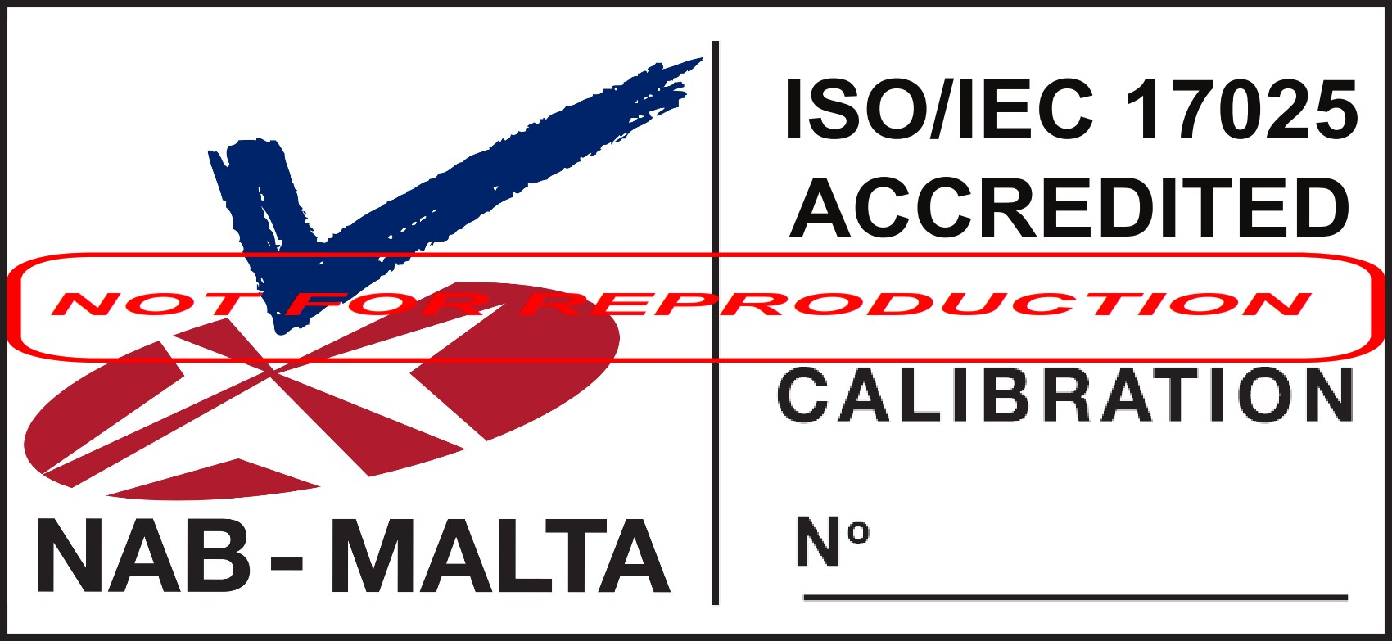 | 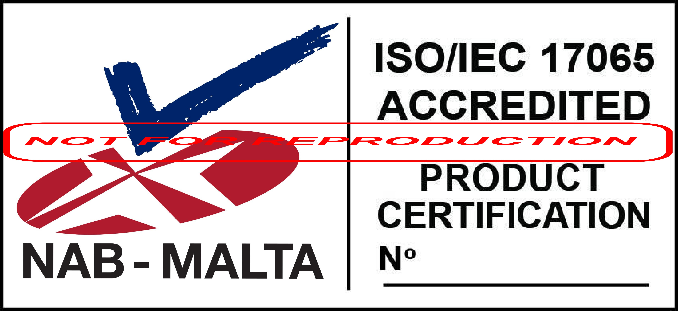
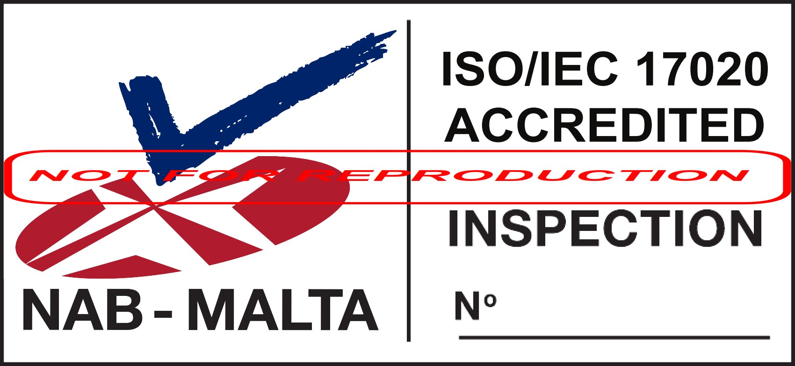 | 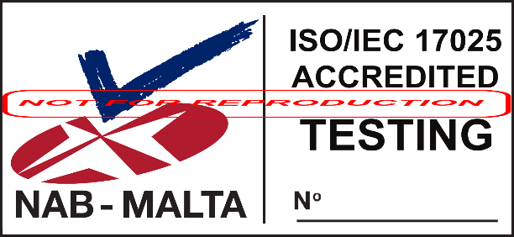

Do you need further information?

This publication, application forms and other information about accreditation including this document, are available for download from the NAB-MALTA website at http://www.nabmalta.org.mt.

The EA (European Co-operation for Accreditation) and ILAC publications referred to in this document are available for free download from http://www.european-accreditation.org.

Should you need any further information we advise you to contact us.

Address:

National Accreditation Board (NAB-MALTA),
1st Floor,
Mizzi House,
National Road,
Blata l-Bajda HMR9010,
Malta

Telephone: (+356) 23952510

E-mail: info@nabmalta.org.mt

END

